# DEPARTMENT OF ENTOMOLOGY

**Entomology Seminar Series**

Speaker:

Benjamin M. Sadd, Ph. D.

School of Biological Sciences, Illinois State University

# Date: Time: Format: Location:

Monday, April 7, 2025

4:00 pm - 4:50 pm

In-Person Seminar & Virtual Access Genomics Auditorium, Room 1102A

**Zoom:** 952 1906 3064

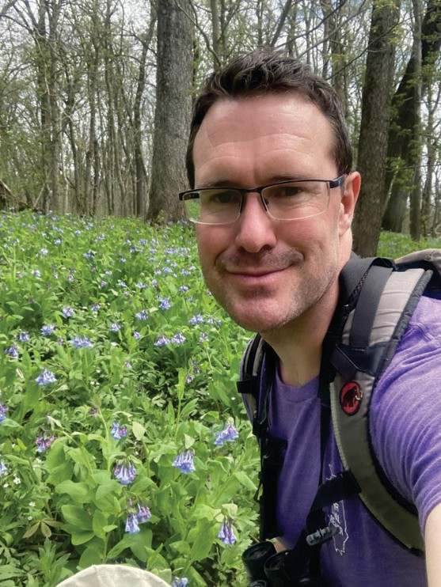

**Passcode:** 505445

# Title:

“From a troublesome gift to terminal investment: Evolved reproductive strategies in decorated crickets”

# Abstract:

We may naively think of sexual reproduction as a purely cooperative endeavor. While intrinsically it is cooperative, sexual reproduction is fraught with conflicts and challenges. These stem from misalignment of optimal reproductive outcomes for mating partners, internal trade-offs, and environmental factors that affect reproduction. Selection from these sources has led to the evolution of an array of reproductive strategies.

Decorated crickets, Gryllodes sigillatus, provide an intriguing and accessible system to study sexual selection, sexual conflict and evolved reproductive strategies. Male decorated crickets use acoustic signaling to attract females, and, at successful copulation, provision females with an endogenously produced nuptial gift. However, this gift does not benefit the female, but is nefarious in nature, increasing male sperm transfer and manipulating female behavior and physiology to the male’s benefit. I will discuss studies spanning from the knock-down of nuptial gift protein gene expression to experimental evolution to reveal the role that the gift plays in sexual conflict and the evolution of female resistance to manipulation under sexually antagonistic coevolution. I will conclude by focusing on male calling and further reproductive strategies in the face of competition from rivals and threats to longevity. The latter examines the dynamic terminal investment threshold, where increased investment into reproduction is cued by impending mortality but this is dependent upon an individual’s residual reproductive value, or potential for future offspring.

https://zoom.us/j/95219063064?from=join#success

*Refreshments will be served in the Entomology Building at 3:30 pm*